INDIAN’S AGRICULTURAL CROP PRODUCTION ANALYSIS (1998-2021)

1. INTRODUCTION

1.1 OVERVIEW

* This report delves into the captivating realm of India’s agricultural cultivation, providing a comprehensive visual exploration of key aspects and trends in the agricultural sector. Through the visual representations, readers can gain valuable insights into crop production, seasonal variation, regional distribution, and overall production trends . These visualizations enable intuitive analysis ,allowing stakeholders to uncover patterns , identify areas of growth

or concern , and make data -driven decisions.

1.2 PURPOSE

* This report not only presents the data in a visually appealing manner but also provides an interactive experience for readers to explore the intricacies of India’s agricultural cultivation . To Extract the insights from the data and put the data in the form of visualizations, Dashboards and Story we employed Tableau tool

**2. PROBLEM STATEMENT &DESIGN THINKING**

* **Specify the business problem**
* Business requirements
* Social or Business impact
* Literature Survey

2.1 EMPATHY MAP

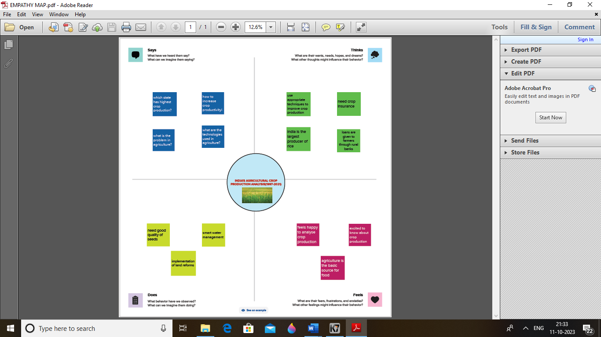

2.2 BRAINSTROMING MAP

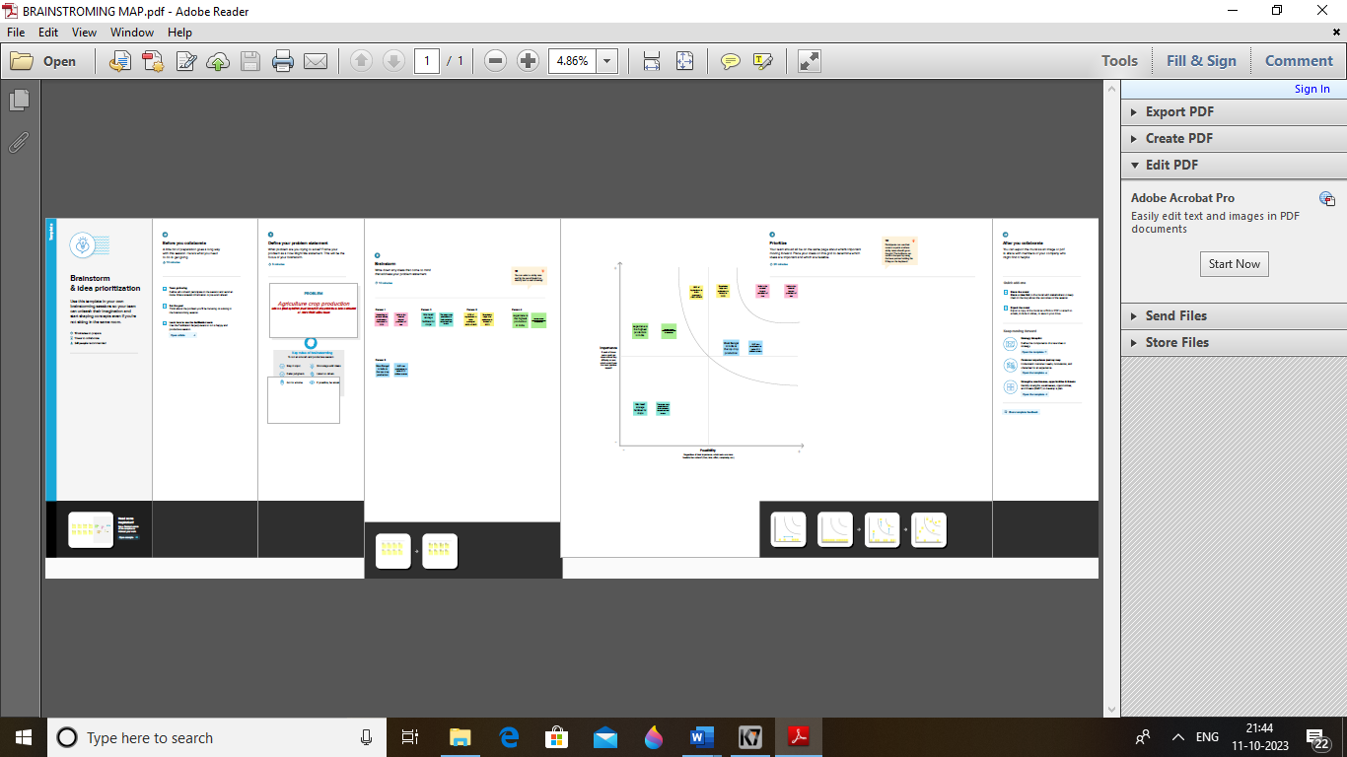

**3.RESULT**

3.1 DASHBOARD

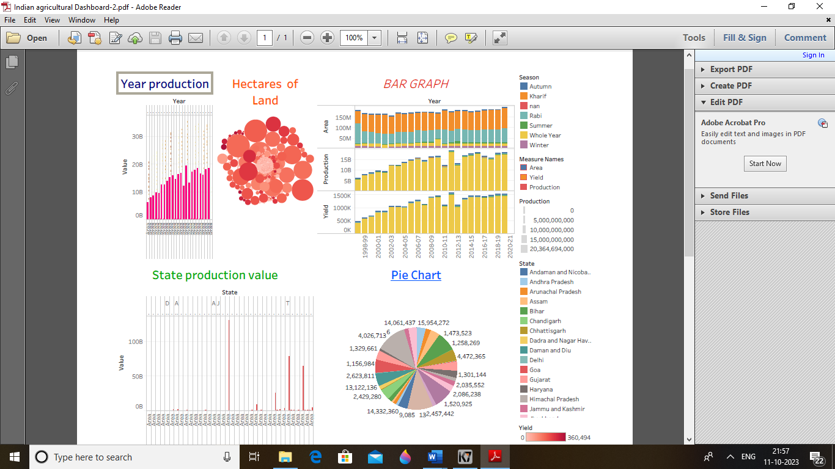

3.2 STORY

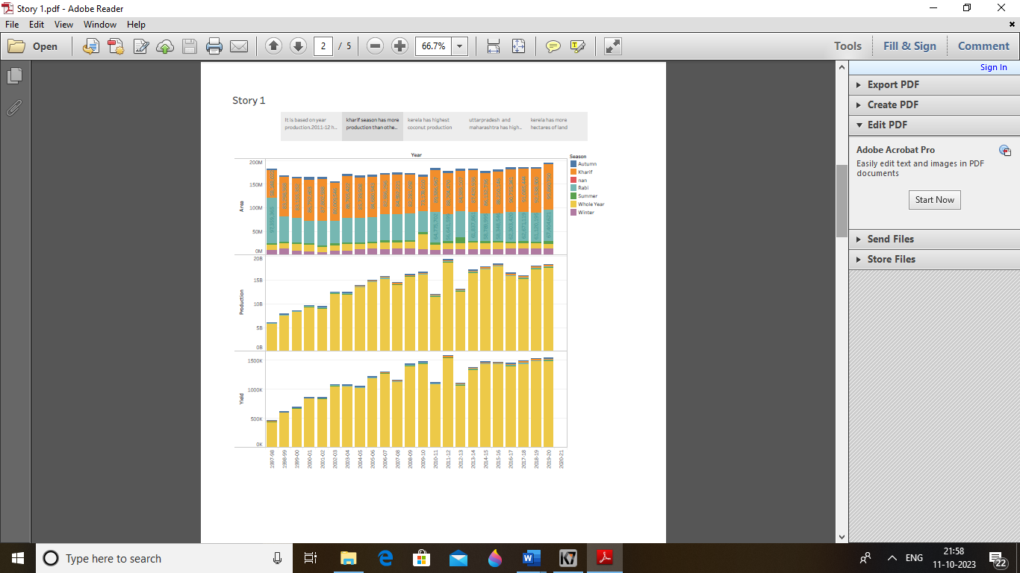

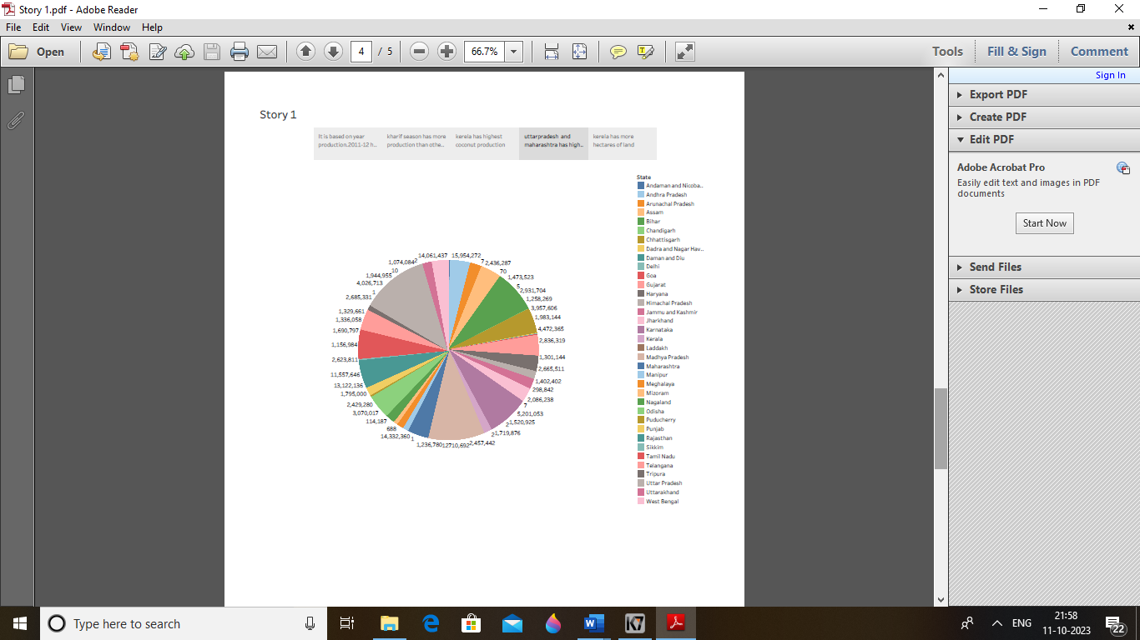

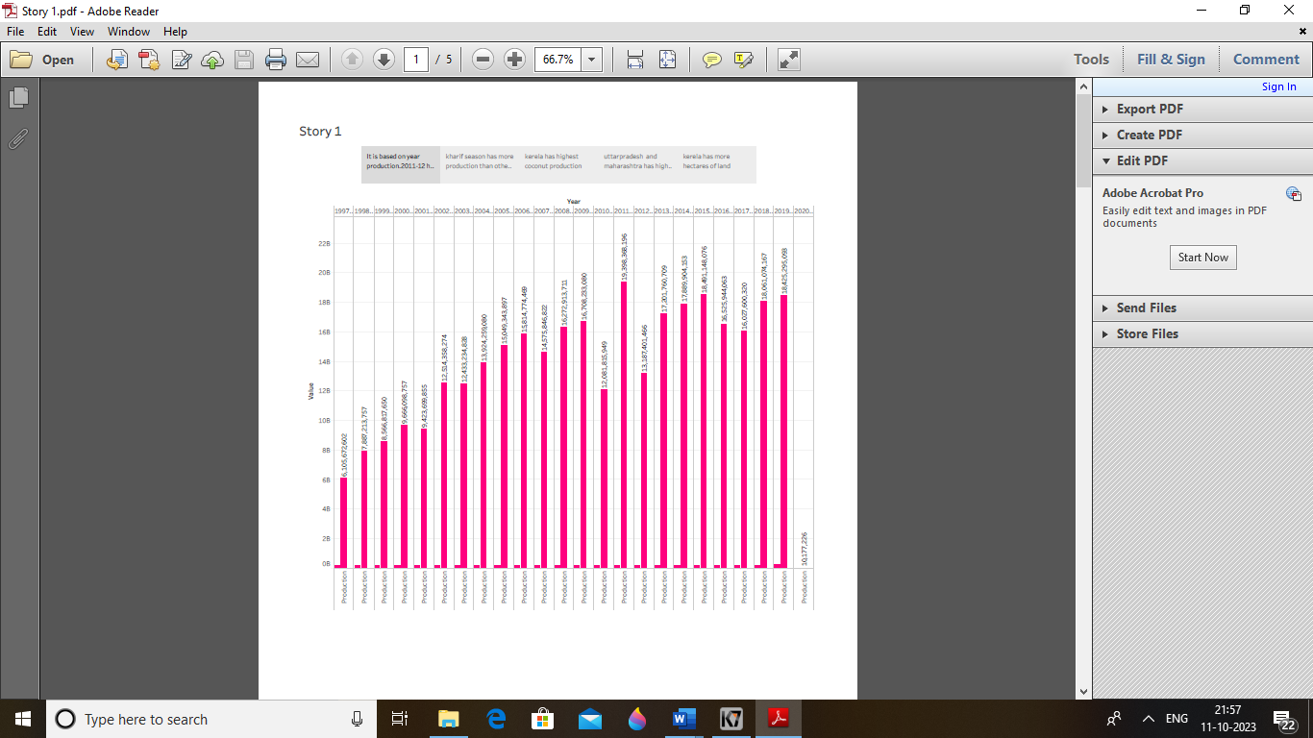

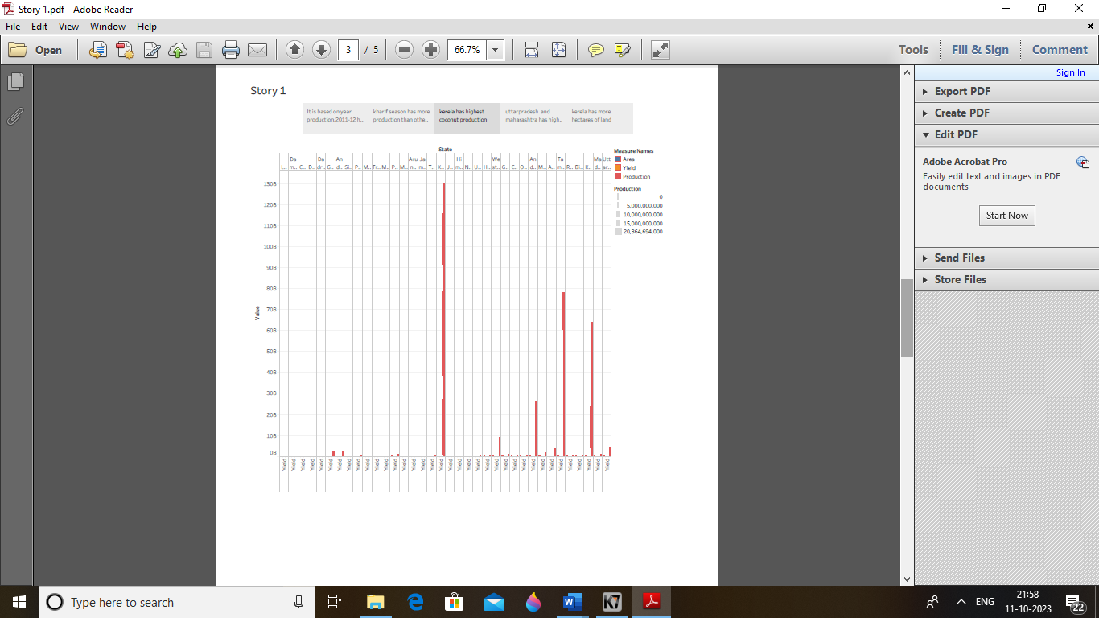

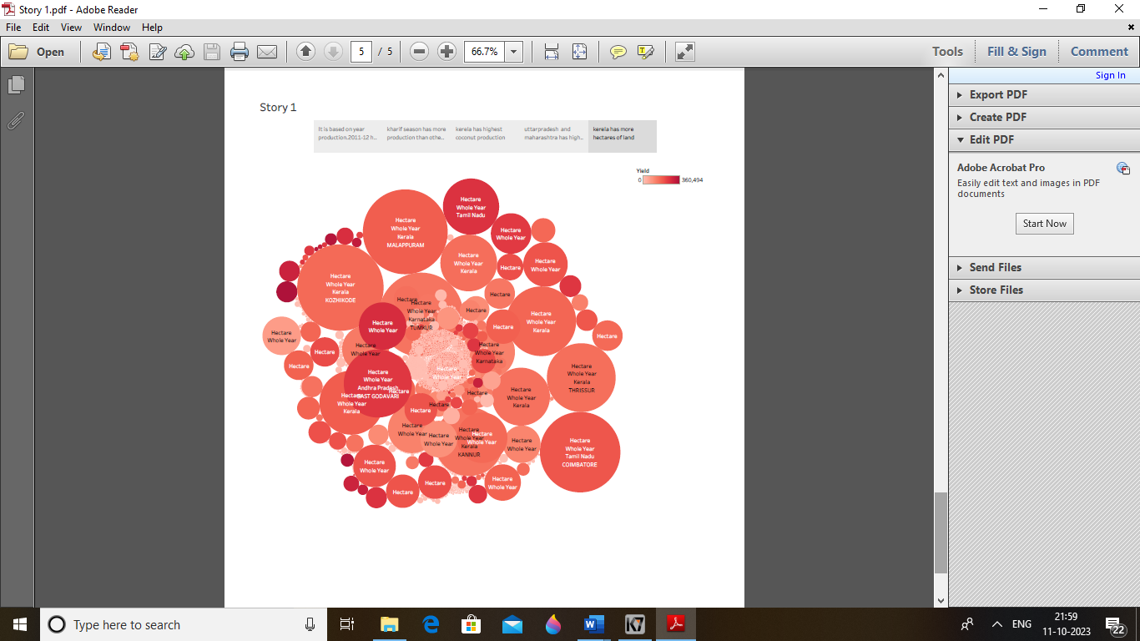

**4.1 ADVANTAGES**

* It is useful to present data and analysis in a narrative manner.
* It is easy to make graph , map and pie chat

**4.2 DISADVANTAGES**

* Tableau does not provide the feature of automatic refreshing .
* Sometimes sign in does not work

**5. Application**

* **Tableau Public**
* **Mural**
* **GitHub**

**6.CONCLUSION**

**Conclusion that summarizes the key findings and high lights their implication .**

**7.FUTURESCOPE**

**In future creating graphical representation of data help people to understand and explore the information. Data visualization help people to identify patterns ,trend and outlines in data.**

**3.3 DATASET**

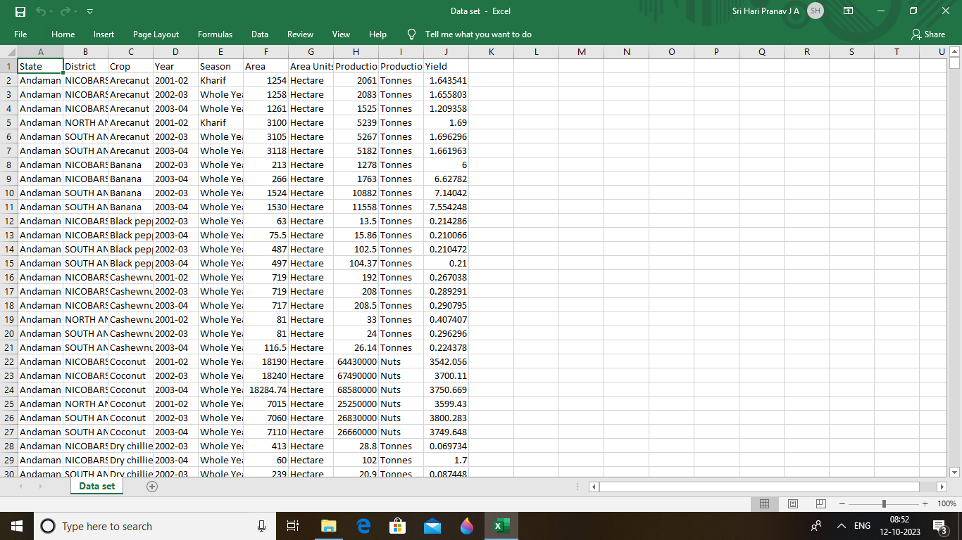

**8.Audio demonstration**

<https://youtu.be/BGRkLC56bMw?si=0BpDmTJTn8Gkjf1q>

**THANK YOU**